LAB 4 TASK

Q1.

#include<iostream>

using namespace std;

class Circle{

private:

double radius;

public:

Circle(double r){ //parameterized constructor

radius=r

cout<<"The area is: "<<getArea(radius)<<endl;

cout<<"The perimeter is: "<<getPeri(radius)<<endl;

}

double getArea(int r){

double a;

a=3.142*r*r;

return a;

}

double getPeri(int r){

double p;

p=2*3.142*r;

return p;

}

~Circle(){ //destructor

}

};

int main(){

double r2;

cout<<"Enter the radius: ";

cin>>r2;

Circle r1(r2); //calling of parameterized constructor

}

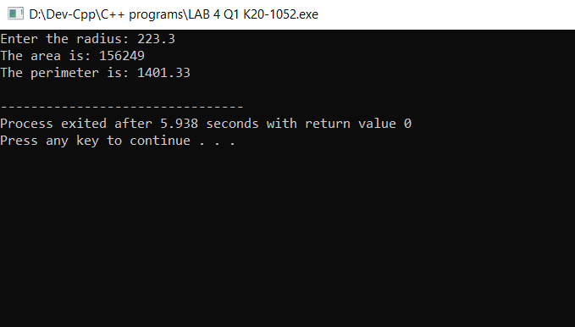

Q2.

include <iostream>

using namespace std;

class Account

{

private:

float accountbalance=9999;

public:

Account()

{

int choice,i;

cout<<"1.Add Balance\n2.Withdraw Balance\n3.Show Balance\n4.Enter any other to Exit\n";

for(i=1;i>=1;i++){ //infinite loop condition

cout<<"Enter your Choice: ";

cin>>choice;

switch(choice){

case 1:

addbalance();

break;

case 2:

withdraw();

break;

case 3:

showbalance();

break;

default:

exit(1);

}

}

}

int addbalance(){

double a;

cout<<"Enter the amount of money you want to add in the current balance of: "<<accountbalance<<" ";

cin>>a;

accountbalance=accountbalance+a;;

cout<<"The current balance after adding money in the account is: "<<accountbalance<<endl;

}

withdraw()

{

double b;

cout<<"Enter the amount of money you want to withdraw: ";

cin>>b;

if(b > accountbalance){

withdraw();

}

else{

accountbalance=accountbalance-b;

cout<<"The Balance after Withdrawal of money "<<b<<" is: "<<accountbalance<<endl;

}

}

showbalance(){

cout<<"The current amount left in your account is: "<<accountbalance<<endl;

}

};

int main(){

Account acc1; //user defined default constructor calling

}

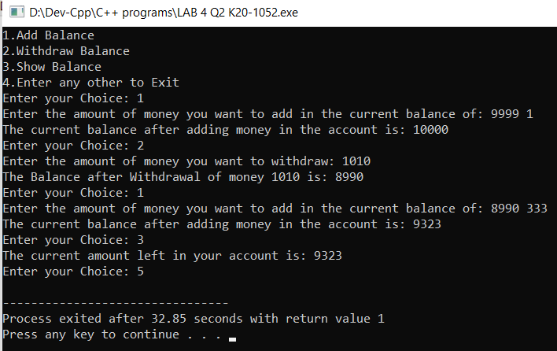

Q3.

#include<stdio.h>

#include<iostream>

#include<iomanip>

#include<string>

using namespace std;

float x=0;

class invoice{

private:

string pn[50];

string pd[50];

int quan[50];

double price[50];

public:

invoice(){

int choice;

double x;

cout<<"Enter the no of purchases: ";

cin>>choice;

cout<<endl;

for(int i=1;i<=choice;i++){

cout<<"Enter the product "<<i<<" no: ";

cin>>pn[i];

getchar();

cout<<"Enter the product details: ";

getline(cin,pd[i]);

cout<<"Enter the quantity of the product: ";

cin>>quan[i];

cout<<"Enter the price of the product: ";

cin>>price[i];

cout<<endl;

getchar();

x= x + amount(choice,quan,price,i);

}

for(int i=1;i<=choice;i++){

cout<<"The Product "<<i<<" no: "<<pn[i]<<endl;

cout<<"The Product detail is: "<<pd[i]<<endl;

cout<<"The quantity of the product: "<<quan[i]<<endl;

cout<<"The price of the a single product: "<<setprecision(2)<<price[i]<<endl;

cout<<endl;

}

cout<<"****************************************";

}

double amount(int choice,int quan[50],double price[50],int i){

double arr;

arr= arr + (quan[i]*price[i]);

// cout<<"amount is: "<<arr<<endl;

if(choice == i){

cout<<"*****The invoice of the hardware store is:*****\n\n";

cout<<"The total amount is: "<<arr<<fixed<<endl;

}

}

};

int main(){

cout<<"\t\t\t^_^_^Welcome to the hardware store^_^_^\n\n";

invoice h1;

}

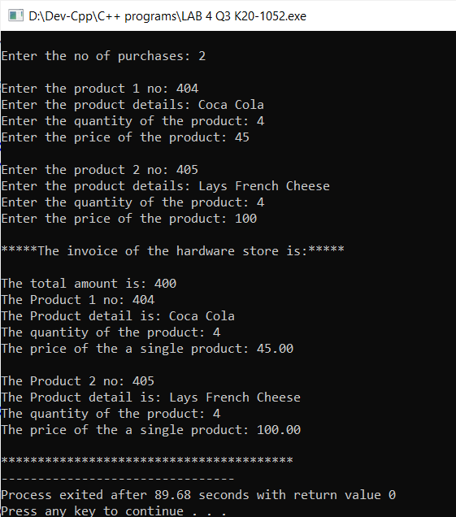

Q4.

#include <iostream>

#include<string>

using namespace std;

class Books{

private:

string author[3];

string title[3];

int price[3];

string publisher[3];

int stkpos[3];

public:

Books(){

author[0]="Jkrolling";

author[1]="KhaledHosseini";

author[2]="J.R.R.Tolkien";

title[0]="Harry Potter";

title[1]="Kite Runner";

title[2]="lord of Ring";

price[0]=3000;

price[1]=2500;

price[2]=4300;

publisher[0]="xyz";

publisher[1]="zyx";

publisher[2]="yzx";

stkpos[0]=5;

stkpos[1]=6;

stkpos[2]=8;

}

display(){

cout<<"The list of books are as follows:\n\n";

cout<<"Book author\tBook title\tPrice\tPublisher\tStockPosition\n";

cout<<author[0]<<"\t"<<title[0]<<"\t"<<price[0]<<" \t "<<publisher[0]<<" \t "<<stkpos[0]<<"\n";

cout<<author[1]<<"\t"<<title[1]<<"\t"<<price[1]<<" \t "<<publisher[1]<<" \t "<<stkpos[1]<<"\n";

cout<<author[2]<<"\t"<<title[2]<<"\t"<<price[2]<<" \t "<<publisher[2]<<" \t "<<stkpos[2]<<"\n\n\n";

}

search(){

string ba,bt;

int copy,aa,x;

float amount;

cout<<"Enter the name of the Book Author: ";

getchar();

getline(cin,ba);

cout<<"Enter the name of the Book Title: ";

getline(cin,bt);

for(int i=0;i<3;i++){

if(ba == author[i]){

if( bt == title[i]){

cout<<endl;

cout<<"The Book is available and the copies that are available are: "<<stkpos[i]<<endl<<endl;

cout<<"Enter the no of copies you want: ";

cin>>copy;

if(copy > stkpos[i]){

x=validcopy(copy,i,stkpos);

amount=x*price[i];

cout<<endl;

cout<<"The book you have bought is: "<<title[i]<<" and the quantity is "<<x<<endl;

cout<<"The amount is: "<<amount<<endl;

}

else{

amount=copy*price[i];

cout<<endl;

cout<<"The book you have bought is: "<<title[i]<<" and the quantity is "<<copy<<endl;

cout<<"The amount is: "<<amount<<endl;

}

cout<<endl;

cout<<"Do you want to buy another book? If yes enter 1: ";

cin>>aa;

cout<<endl;

if(aa == 1){

search();

}

}

else{

cout<<endl;

cout<<"Enter the correct name of Book Author or the Title: "<<endl;

search();

}

}

}

}

int validcopy(int copy,int i,int stkpos[3]){

cout<<"Required copies not in stock,Enter the valid no of copies: ";

cin>>copy;

if(copy > stkpos[i]){

validcopy(copy,i,stkpos);

}

else{

return copy;

}

}

};

int main(){

Books b1;

cout<<"MENU\n";

cout<<"1.Display books\n2.Search book\n3.Exit\n\n";

int choice;

cout<<"Enter the choice: ";

cin>>choice;

switch(choice){

case 1:

b1.display();

main();

break;

case 2:

b1.search();

main();

break;

default:

exit(0);

break;

}

}

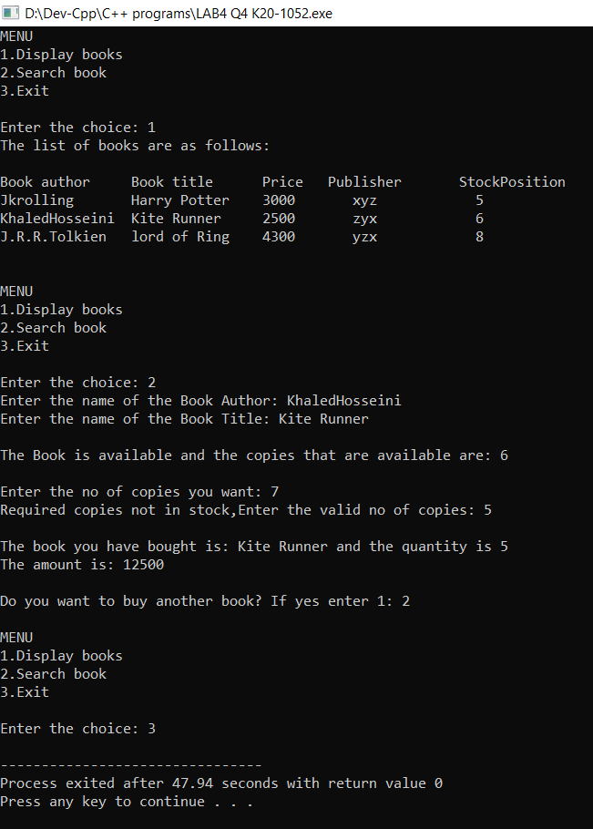

Q5.

#include<stdio.h>

#include<iostream>

#include<iomanip>

#include<string.h>

int i,l;

int p,q,r,s;

int k=0;

using namespace std;

class Coffeeshop

{

private:

string name = "\n\t\t\t***Das deutsche Café(In German)***\n\n";

string menu[3] = {"Tea","Juice","Coffee"};

string orders[10];

public:

Coffeeshop ()

{

cout<<"\t\t\t\tWELCOME TO COFFEE SHOP!!\n"<<name<<"\t\t\t\tBelow is our menu\n";

for(i=0;i<3;i++)

{

cout<<"\t--> "<<menu[i]<<endl;

}

cout<<"\tEnter your choice of order: ";

string n;

cin>>n;

addorder(n);

fulfillorder();

listorder();

dueamount();

cheapestitem();

drinksonly();

foodonly();

}

drinksonly()

{

cout<<"\n\n Currently we have only 3 drinks item\n";

for(i=0;i<3;i++)

{

cout<<endl<<menu[i];

}

}

foodonly()

{

cout<<endl<<"\n\tToday is Sunday and we keep drinks only for this day\n*";

cout<<endl<<"\n\tCome Tomorrow for the food items. Thanks for coming\n";

}

cheapestitem()

{

int c1=50,c3=30,c2=100;

if(c1<c2 && c1<c3)

cout<<"\n\n\t\t\t Cheapest item on menu is tea ";

else if(c2<c1 && c2<c3)

cout<<"\n\n\t\t\t Cheapest item on menu is juice ";

else

cout<<"\n\n\t\t\t Cheapest item on menu is coffee";

}

dueamount()

{

cout<<"\n \t ONE cup of Tea = 50 \n \t ONE Glass of Juice is = 100 \n \t ONE cup of Gold Coffee is = 30\n";

string u = "Tea";

string m = "Juice";

string e = "Coffee";

for(int i=0;i<10;i++)

{

if(u==orders[i])

{

p++;

}

else if(orders[i]==m)

{

q++;

}

else if(e==orders[i])

{

r++;

}

}

float bill = (p*50) + (q*100) + (r*30);

cout<<"\n\t You need to pay amout of: "<<bill;

}

listorder()

{

cout<<"\n\n\t List of orders taken\n";

for(i=0;i<10;i++)

cout<<orders[i]<<endl;

}

fulfillorder()

{

string bb;

if(orders[i]!=bb)

for(int i=0;i<10;i++)

{

cout<<"\n\t the "<<orders[i]<<" is ready\n";

if(orders[i+1]==bb)

break;

}

else

cout<<"\n\t All orders have been fulfilled";

}

void addorder(string a)

{

for(i=0;i<3;i++)

{

if(a==menu[k] || a==menu[k+1] || a==menu[k+2])

{

orders[i] = a;

cout << "\n\n\tORDER noted";

cout<<endl<<"\t-"<<orders[i];

yes(a);

cout<<"\n WE break";

break;

}

else

cout << "SORRY!! This item is currently unavailiable";

break;

}

}

}

int yes(string x)

{

cout<<"\n\t Want to order again enter 1 else press 2: ";

int ch;

cin>>ch;

if(ch==1)

{

cout<<"\n\tEnter your choice of order: ";

string j;

cin>>j;

if(j==menu[k] || j==menu[k+1] || j==menu[k+2])

{

orders[i+1]=j;

i++;

yes(j);

}

}

else

{

cout<<"\n you pressed 2";

return 0;

}

}

};

main()

{

Coffeeshop b1;

}

